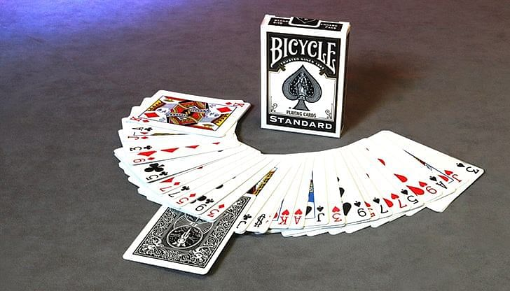

# Project

This lab continues work on the project from **Lab 1**. Be sure to make any needed corrections to Lab 1 before beginning on this assignment.

Using the ***Card*** class and supporting classes such as ***Face*** and ***Suit*** from your exercise last week, create a ***Deck*** class representing a deck of cards. The class should demonstrate the ***composition*** ***relationship*** with the Card class as shown in the ***UML*** diagram below. The **composition relationship** here says that a ***Deck*** has an array of ***Card*** objects as an ***attribute*** and the ***Card*** objects are created by ***Deck’s*** constructor. A deck has exactly 52 unique cards.

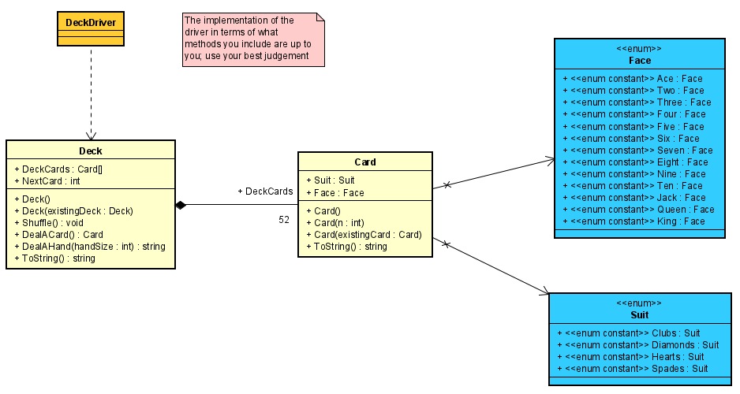

Add a ***driver*** that creates and displays an entire ***Deck*** of ***Cards***, shuffles the ***Deck*** and displays it again, creates another ***Deck*** as a copy of the first ***Deck***, and deals and displays two hands of 7 ***Cards*** each from that second ***Deck***. You may discard the driver class from the previous exercise and replace it with this one. Do **NOT** include the driver from the previous exercise.

# Hints and Other Specifications

1. **Deck’s attributes** should be **public properties**, but should have a **private set**; there is never a need to change either attribute outside of the Deck class.
2. The ***Deck’s*** ***default*** ***constructor*** should fill an array of 52 unique ***Card*** objects. Use a loop and pass the loop’s counter to the ***Card*** constructor as its argument.
3. The ***Deck*** class should have a ***copy*** ***constructor*** that does a ***deep*** ***copy***.
4. The ***ToString*** method should return a string that contains 52 lines – one for each of the ***Card*** objects in the ***Deck’s*** array of ***Card*** objects, ***DeckCards***. It should use the ***Card*** class’ ***ToString*** method to do part of the work.

**Hint:** create the above 3 methods first so that you can use them to test whether other methods are working correctly as you implement each of them, one at a time.

1. The ***NextCard*** attribute is a counter that is initialized by the ***constructor*** to 0 and reset to 0 by the ***Shuffle*** method. It should be incremented every time a ***Card*** is dealt from the ***Deck***. It is used internally by the ***Deck*** class to keep track of which of the 52 ***Cards*** is to be dealt next. See the diagram below.
2. The ***Shuffle*** method shuffles the array of ***Card*** objects by looping through the array of ***Card*** objects one position at a time and exchanging (see **slides** **56-57** of the array supplementing PowerPoint) the ***Card*** in that position with the ***Card*** in a random position (as determined by a ***Random*** number) between 0 and 51.

To further randomize the order of the cards, one may repeat the full shuffling loop several additional times (equivalent to shuffling a deck of cards by hand several times).

1. The ***DealACard*** method returns the ***Card*** from the array of ***Card*** objects in position ***NextCard***. See the diagram below that illustrates how this should work.
2. The ***DealAHand*** method has a loop that deals one ***Card*** (using the ***DealACard*** method) at a time until it has dealt ***handSize***number of ***Cards***. The ***string*** returned is a list of the ***Card*** objects in the hand – similar to the result of ***ToString*** except that the ***string*** returned here contains only ***handSize*** number of ***Card*** objects.

|  |  |
| --- | --- |
| ***NextCard*** is an integer variable initialized to 0.   * It is used as a pointer to keep track of which ***Card*** is to be dealt next – initially ***DeckCards[0]*** – see the state of the diagram to the right that shows ***NextCard*** referring to the ***Card*** in position ***0*** * Each time a ***Card*** is dealt from the ***Deck***, add one to ***NextCard*** so that it points to the next (as yet) **undealt** ***Card*** in the array * Be sure not to allow ***NextCard*** to go beyond ***51*** (the subscript of the ***last Card*** at the ***end of the deck***) | ***DeckCards* - array of Cards in Deck Class** |
| **NextCard→** | **Card 0** |
|  | **Card 1** |
|  | **Card 2** |
|  | **Card 3** |
|  | **Card 4** |
|  | **Card 5** |
|  | **Card 6** |
|  | **.**  **.**  **.** |
|  | **Card 49** |
|  | **Card 50** |
|  | **Card 51** |

# Proper Documentation is Required

Make sure **all** code files are [**fully documented**](http://csciwww.etsu.edu/bailes/courses/1260/LectureMaterial/Policies%20Regarding%20Code%20Documentation.docx)– see the [**course documentation policies**](http://csciwww.etsu.edu/bailes/Courses/1260/LectureMaterial/Policies%20Regarding%20Code%20Documentation.docx) posted on D2L for the conventions and requirements including examples of proper documentation. Proper documentation includes following the naming conventions for classes, files, methods, variables, constants, and other identifiers.

# Submission

Your submission should be a single **.zip** file with a name in the format of ***1260-LastFirst-Lab2*** containing your entire VS project. Submit the **one** **zipped** **file** to the **Lab 2 Dropbox** on D2L.

# Sample Output

